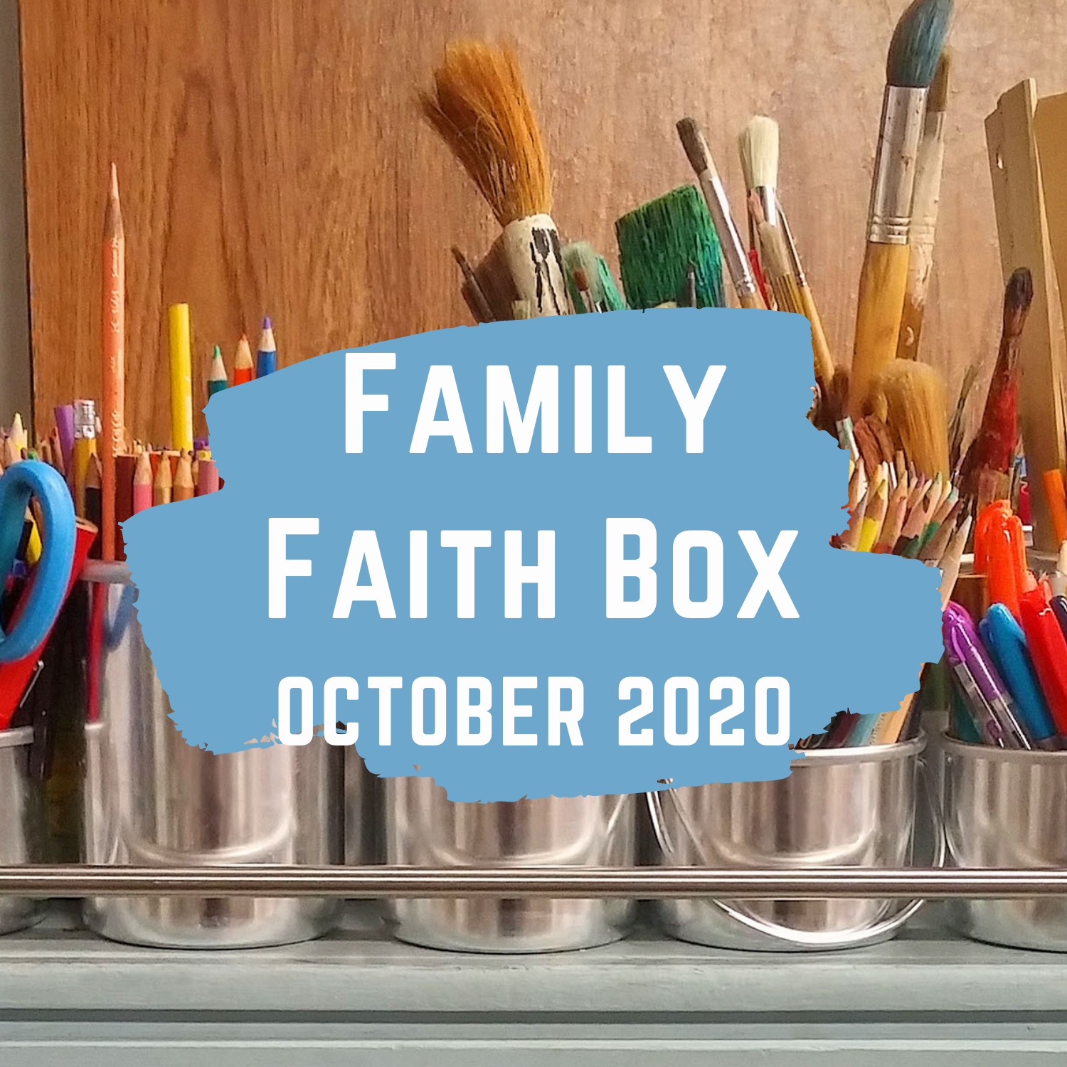

Dear Families,

I’m so glad that you’ve signed up for our Family Faith program! I hope that these stories and activities help you all to learn and grow in faith as a family. Each Friday there will be a video and devotional sent out via email and posted on lcpc.net. Those are intended for Sunday morning, but can be watched/read at any time. The activities in this packet are intended to supplement that content, whether over the weekend or throughout the week. And always feel free to skip any activities that don’t fit your family! I try to include a variety of options for all kinds of different kids.

This month we are getting close to finishing up our journey through the Old Testament, which we have been steadily working our way through on Sunday mornings for 2 years now. Some of these stories aren’t told very often, while others are more well-known. November will bring the end of the Old Testament, Thanksgiving, and...the start of Advent! But I’m getting a little ahead of myself.

I am praying for all of you, and while I wish we could all spend time together in person, I’m glad that this program helps families dig into God’s Word together. My hope is that each week everyone in your family learns something new! (I know I learned plenty of new things putting these activities together!)

As always, I’m here if you have any questions, or if you need a listening ear. Please don’t hesitate to reach out.

In Christ,
Kristy Hicks
Interim Director of Children’s Ministries

Week of October 4th
Captives Come Home/Temple Rebuilt
Main Idea: God always keeps his promises
Background:
God’s people had been living in Babylon for 70 years. Many of God’s people had been born in Babylon, but they had likely heard the stories of their parents and grandparents, stories of a life in the land God had given them. They probably heard of their families’ mistakes: ignoring God, worshiping idols, and mistreating the poor. But the Lord had been gracious! He kept His promise to bring His people back to Judah.
Before the people of Judah were exiled, God had spoken through the prophet Jeremiah. These are the words of the Lord: “These nations will serve the king of Babylon for seventy years” (Jer. 25:11). Then the Lord said, “When seventy years for Babylon are complete, I will attend to you and will confirm my promise concerning you to restore you to this place” (Jer. 29:10). The time had come for God’s people to go back home. Cyrus, the king of the Persian empire, had overthrown Babylon. Cyrus took over the kingdom, including the lands of Israel and Judah. In the following year, the Lord did something miraculous in Cyrus’s heart. He prompted Cyrus to issue a decree: All the Jewish exiles are free to return to their ancestral homes. The exile was over! God’s people were free to return to their own land. They were free to live as God’s special people. The first group of Judean exiles returned home under the leadership of Zerubbabel (zuh RUHB uh buhl). Zerubbabel was the grandson of King Jehoiachin, who had been taken to Babylon by King Nebuchadnezzar. (See 2 Kings 24:8-13.) Ezra 2:64-65 says nearly 50,000 people traveled back to Judah. When they got to Jerusalem, they began working to rebuild the temple that the Chaldeans had destroyed. (See 2 Chron. 36:19.) Explain to kids that the temple was the place where God met with His people. Jesus came to earth to rescue God’s people from sin. When Jesus returns, He will restore the earth and will dwell with His people forever.

Game: Treasure hunt
There will be gold-colored plastic coins in your box. While kids aren’t looking, hide the coins around a room (or around the entire house!). Then have kids look for the gold coins. Once they’ve found all of the coins, remind them that in our story this week, God’s people returned home from living in a foreign country for 70 years! And when they went home, the people of Babylon gave God’s people gold and silver coins, as well as other gifts.

Art:
There will be a paper suitcase pattern in your box. Show children how to fold the pattern in half to create a suitcase that opens. Guide children to open their suitcase and draw items with crayons or markers that they would pack if they were moving. Encourage them to decorate the outside of their suitcases with stickers, crayons, or markers.
While working on the activity, talk with kids--if you had to move what would you pack in your suitcase to take with you? Remind kids that God’s people had to move everything they had in Babylon back to Judah. On the front of your suitcase it says, God kept His promise to bring His people home. Someday Jesus will come back. He will fix up an even greater home for all of God’s people, and we will live with Him forever.

Music: Make tambourines
There will be plates with holes punched around the outside edge, ribbon, and dried pasta or beans in your box. Help kids tie the plates together with ribbon, leaving a gap to add the pasta/beans. You can add extra ribbon as decoration on the tambourine. Fill the plates with dried pasta or beans. Then finish tying the plate together. Finally, use colored markers to decorate the face and back of the tambourine. Invite kids to shake their tambourines. Talk about how God’s people celebrated after they finished their work. They celebrated the completion of the temple, and they celebrated God’s faithfulness. God helped His people rebuild the temple. He gave them strength to obey Him.

Week of October 11th
Zechariah
Main Idea: The whole Bible points to Jesus!

Background:
Zechariah was a priest who had been born in Babylon. He had returned to Jerusalem with Zerubbabel. At this time, the prophet Haggai was bringing God’s message to His people. The Judean exiles were struggling to finish rebuilding God’s temple. In fact, several years had passed without progress on the temple when God called Zechariah to prophesy to His people. Zechariah’s message was twofold: first, look back and remember the past. Second, look forward and prepare for the future. God wanted His people to learn from the mistakes of their parents and grandparents who had ignored the prophets’ warnings. Zechariah set out to encourage the people. The Book of Zechariah is organized into eight visions, four messages, and two oracles. The visions Zechariah saw each symbolized something God would do—such as rebuild Jerusalem, judge Israel’s enemies, and remove national sin. (See Zech. 1–6.) A couple of years later, God spoke to Zechariah again. This time, God spoke four messages to respond to a question the people had about fasting. (Zech. 7:3) In the last six chapters, Zechariah changed the subject to the future of God’s kingdom. Chapters 9–12 are rich with Messianic prophecy; the words are quoted often in the New Testament. Compare Zechariah 9:9 with John 12:15; Zechariah 11:13 with Matthew 27:9; and Zechariah 12:10 with John 19:37. As you talk with kids about Zechariah, emphasize God’s promise: “A king is coming.” Zechariah’s visions were significant to the reality of God’s people at that time, but a greater reality awaited. Zechariah pointed to Jesus, the coming deliverer who would be struck and pierced to take away sin. God would deal with His people’s enemies. He would cleanse His people. “They will call on my name, and I will answer them; I will say, ‘They are my people,’ and they will say, ‘The Lord is our God” (Zech. 13:9). Under the rule of King Jesus, our future is incredibly bright.

Game: Guess the Future!
In your box will be four different colored sheets of construction paper. Place one sheet in each corner of a room. There will also be a cup with 4 small papers inside (one for each color). Invite the kids to see if they can guess the “future” by standing near the color you are going to draw out of the cup. After each kid has made a choice, draw out a color. Remind kids that we can’t know the future! Only God knows the future, though in our story he shared a little bit about the future with Zechariah through something called a vision. Ask kids if they remember one thing that God showed Zechariah.

Craft: Lampstand
Your box will have a white styrofoam cup for each child, yellow construction paper, and red, orange, and yellow tissue paper, along with stickers or slips of paper with Zechariah 9:9 printed on them. The styrofoam cup will have the bottom removed.

First, have kids stick or glue the verse to the upside down cup. Then have them roll up the yellow construction paper and place it in the cup. Finally, stack up pieces of red, yellow, and orange tissue paper and roll up the bottom slightly to stick it in the yellow construction paper so it is sticking up over the top like a flame.

The finished product should look something like this:
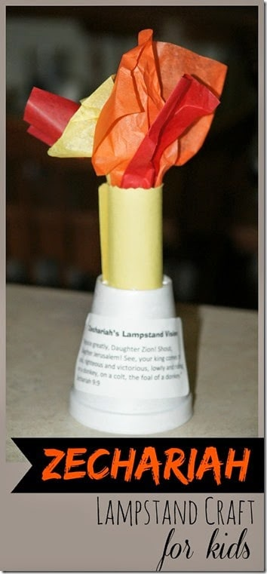

Talk with kids about how one of the visions Zechariah had was of a lampstand, which looks sort of like this. The lampstand in his vision meant that all of God’s plans were going to happen. God always keeps his promises!

Game: Pin the King on the Donkey
There will be a Donkey cut-out and a few paper “Kings” in your box. Make small loops of tape to place on the back of each king. One by one, blindfold each person playing, spin them around, and allow them to attempt taping a king to the donkey. The kid who gets the closest after each player has had a turn wins. Remind kids that Zechariah prophesied about the coming Messiah by saying that Israel’s king would come into Jerusalem riding on a donkey. That doesn’t sound like a very grand entrance for a king. This exact prophecy was fulfilled when Jesus rode into Jerusalem on a donkey.

Week of October 18th
Esther
Main Idea: God is in control of everything, and His timing is perfect.

Background:
The Babylonian captivity ended when Cyrus, the king of Persia, took over Babylon and let God’s people go home. Some of God’s people—now called Jews (people from Judah)—traveled back to Judah to rebuild the temple, the city, and their lives. Others, however, stayed in Persia where life among the pagans was relatively comfortable. The king of Persia was now Ahasuerus (uh haz yoo EHR uhs), also known by his Greek name, Xerxes (ZUHRK seez). Esther was a young Jewish girl who became queen of Persia. The former queen had defied the king and was promptly replaced. Esther had been an orphan, so her cousin Mordecai adopted her. Mordecai kept in touch with Esther while she lived in the palace. One day, the king gave Haman the Agagite a very important position in the kingdom. The king even commanded the people to bow down to Haman. But Mordecai refused. Haman was a descendant of Agag, king of the Amalekites. The nations of Israel and Amalek did not get along. Haman was angry, but instead of just punishing Mordecai, he planned to kill all the Jews in the kingdom. In today’s Bible story, Mordecai turned to Esther for help. After all, she was in a position of power, and the Jews were her people. The stakes were high, but Esther approached the king and explained her people’s plight.

Art
Your box will have cut-outs of Queen Esther, 1-inch pieces from gold chenille stems and 1-inch pieces from black or brown yarn. Guide kids to draw a face and color clothing. Invite them to cut out their puppets then glue on sequins, yarn for hair, and a chenille stem piece for a crown. Then tape a craft stick on the back of each puppet. Encourage kids to tell the Bible story using their puppets. While working on the craft, you can discuss how the king chose Esther to be his queen. The king did not know God was in control of his choice. God made Esther queen, and God used Esther to rescue God’s people from their enemies.

Game:
There will be a yellow star cut-out in your box. Tape the star to the end of a ruler or marker to create a scepter. Have one person in your family be “king” and stand in front of the rest of your family. Then have everyone else line up at the opposite end of the room. When the king’s back is to the group, everyone will walk forward. When the king turns around with his scepter held down, everyone must freeze. Anyone the king sees moving must go back to where they started. The first person to reach the king, is the next king.
Talk about how King Ahasuerus could punish people who came to see him unless he asked them to come. Queen Esther must have been afraid to go to the king, but God was with her. The king held out his scepter and asked what he could do for her. God used Esther to rescue God’s people from their enemies. God was in control!

Support a Community Helper:
Think of a church member or someone in the neighborhood who serves the community. (Examples: firefighter, police officer, doctor or nurse, military personnel, missionary, and so forth). Either write notes thanking this person for what they do, or consider doing something else to help them feel appreciated. (If you need help thinking of people who serve the community, let Kristy know, she can point you towards someone!)
Then talk about how Esther agreed to help her people. This wasn’t an easy decision! Esther was very brave. Consider praying for the people in our community who are willing to give up their time, their safety, and even their lives to help those in need.

Bonus Option: Family Feast
In our story this week, we learned about Esther inviting the king to a feast. Consider making a special dinner (have kids help you set the table, perhaps with a special tablecloth (even one from the dollar store!) and decorate it for a feast. Maybe serve something that you might not typically eat, or have a typical meal but use special dishes! Or, if you would rather, have a pretend feast! Talk about what makes certain meals special. In our story this week, Esther invited the king to a feast because she had to talk with him about something VERY important. Ask kids if any of them remember what she was asking him about!

Week of October 25th
Nehemiah (Walls Rebuilt)
Main Idea: God is always faithful!

Background:
Nehemiah was a Jew living in Persia. He served as the king’s cupbearer. When the Persian Empire conquered the Babylonians, King Cyrus allowed God’s people to return to Judah. Two or three million Jews had originally been deported, but only a remnant—50,000 people—returned. They set up their homes and rebuilt the temple in Jerusalem. But when God’s people faced opposition in rebuilding the rest of Jerusalem, they stopped. Some 70 years passed, and the walls and gates around the city were still ruined. City walls and gates were very important in Bible times. Thick walls protected a city from its enemies and provided a sense of safety and security. Gates were the center of city life, the meeting place for commercial and social transactions. Without these structures, the surviving remnant of God’s people struggled and was vulnerable to attack. Nehemiah traveled from Persia to Jerusalem to lead the effort in rebuilding Jerusalem’s walls. His leadership was effective. Nehemiah 3 describes all the people working together to rebuild the gates and walls. But it wasn’t long before Nehemiah met opposition from local governors. God’s people armed themselves and kept working, completing the wall in just 52 days. Note how their enemies reacted: “All the surrounding nations were intimidated and lost their confidence, for they realized that this task had been accomplished by our God” (Neh. 6:16). Now God’s people were protected from their enemies. Help kids see that God provided the way for us to be protected from our enemies, sin and death: He sent His Son, Jesus, to die on the cross for our sins. When we repent and trust in Jesus, He frees us from sin and death. We still sin, but we are no longer slaves to sin. (See Rom. 6:17-18.) We may die a physical death as a result of sin, but we have eternal life. (See John 11:25-26; Rom. 6:23.)

Craft: Make a picture of a city
Your box will have gray and blue paper. Encourage children to cut rectangles from gray or tan construction paper and glue them on blue paper to make a city. Suggest that they use markers to draw windows and doors on their houses and buildings. Talk about the area where you live and discuss if it is a city, town, or rural area. Remind kids that cities often have buildings that are close together and many people live there. Long ago, cities had walls around them to keep the people safe. We heard about a city with walls in our Bible story this week!

Activity: Build walls out of cups
There will be a stack of cups in your bag. Work together to use all of the cups to make a wall. After you’ve built the wall, you can also play a game: have some of your family try to defend the walls from being knocked down by a ball or bean bag! Remind kids that walls were built around cities to keep the city safe. In our Bible story this week, they had to rebuild the walls around Jerusalem because they had been knocked down.

Game: Race to the Gates
There are several gates mentioned in chapter 3 of Nehemiah. For this game, we will be discussing four of the gates: Sheep, Horse, Fish, and Fountain.
There will be pages in your box with pictures that represent the gates. Place them in different places in a room (or outside). When you call out the gate, your child/children must rush to that gate! You can have kids race, or for younger kids, praise them for finding the correct gate!

Bonus Option:
Find something in your house that is broken, but fixable. (Ex: A ripped page in a book, a toy that needs to be glued back together, etc.) Gather the materials needed and fix it together! Remind kids that the walls of Jerusalem were broken and destroyed, but the people came together to build them again!

Week of November 1st
Nehemiah (God’s People Repented)
Main Idea: God’s Word changes us.

Background:
Ezra was a priest in Babylon at the end of the exile. More than 50 years after the first group of exiles returned to Jerusalem and completed and dedicated the temple, Ezra led a second group back to Jerusalem. Just as God had been with Nehemiah, He was with Ezra—granting him favor with the Persian king. The king gave Ezra permission to go to Jerusalem. He provided Ezra with a letter and access to resources to ensure safe travel. (See Ezra 7:11-26.) Ezra traveled to Jerusalem with a purpose. God’s people had spent 70 years in exile, and they needed to be reminded how to live. As a scribe, Ezra was an expert on the law of Moses, and he had “determined in his heart to study the law of the Lord, obey it, and teach its statutes and ordinances in Israel” (Ezra 7:10). Under Nehemiah’s leadership, the people had rebuilt Jerusalem’s walls. They gathered together at the Water Gate to hear the law of Moses. Men, women, and children—anyone who could understand—came to listen to the reading of God’s Word. From early morning until midday, Ezra read from the book of the law of Moses. He stood on a high wooden platform where everyone could see and hear him. Ezra opened the book of the law, and everyone stood up. The Levites helped the listeners understand the words of the law. The people reacted strongly to hearing and understanding the law of Moses. Verse 9 says the people wept. The law revealed their sin, and they repented. God’s Word is powerful!

Art: Make a Coffee Filter Sun
Give each child a flattened paper coffee filter. Guide kids to use yellow, orange, and red markers to color their coffee filter. Then have kids set their colored coffee filter on a towel and use a spray bottle to spray the filter with water. Point out how the colors blend together. Talk about how in this week’s Bible story God’s people—men, women, and children—got together early in the morning when the sun was just coming up. It was a special day.

Activity: Molded and Re-molded
Give each person in your family a piece of play-dough. Have everyone mold their dough into a shape of their choosing. After a minute or so, have everyone give their creation to someone else. Then reshape the clay into something new. In a minute or two, have everyone pass their sculptures again, and again change the work into something new. Talk about how sometimes it can be really difficult to give up control over things in our lives, like our sculptures. We don’t always like it when other people change things and make them different. God’s people refused to give God control of their lives for a long time. But when God brought His people home and helped them finish the walls and the temple, Ezra read God’s law to the people. God’s Word changed them! They threw a celebration to honor God for His faithfulness and power.

Worship through song
Ask kids how they worship. Remind them that we worship by singing songs, listening to Bible stories, praying, and learning more about God and Jesus. In our story, how did the people worship? They listened to Ezra read the scroll; they lifted their hands to praise God; they bowed down to pray. God’s people promised to obey God. We can worship as a family by singing together!
Find a worship song that you all like and play it. Sing together, or perhaps if you have some rhythm instruments, play along with those!

